- HUD

Ammo on bottom right, change color when low, with flash when it turns low and audible noise;
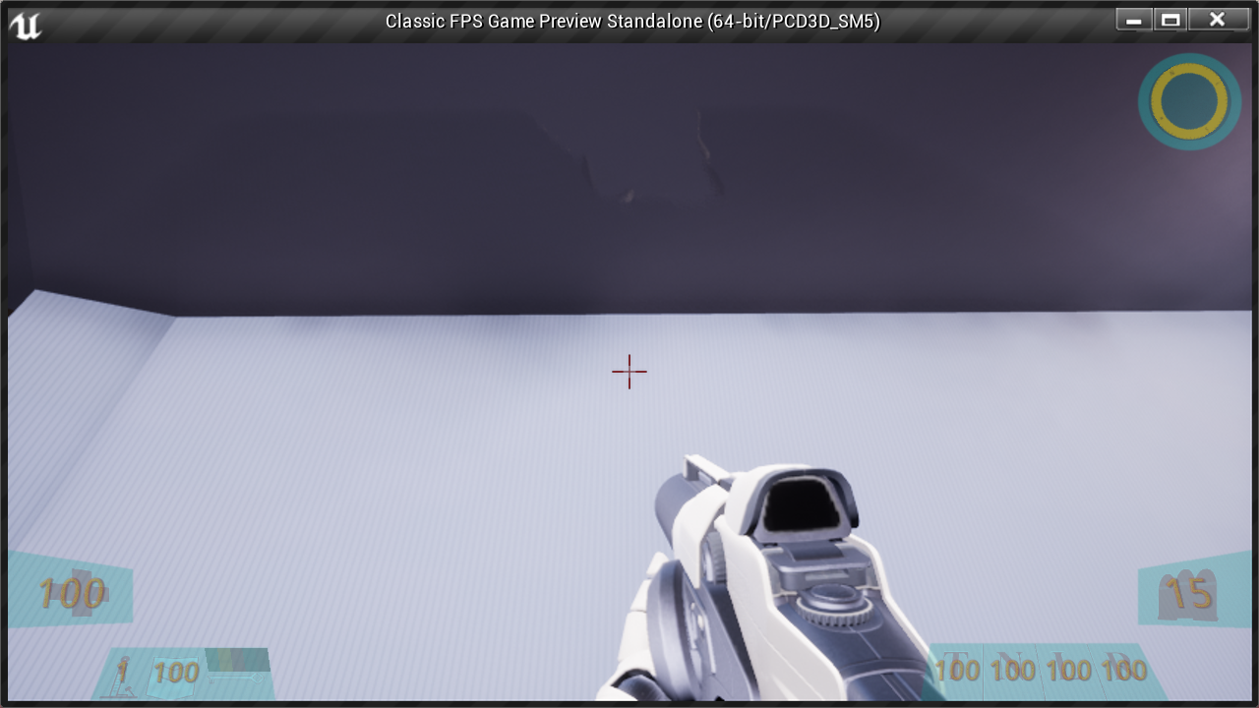
Radar Top right (as a powerup?), different color for enemies that are close; compass style
Health on bottom left; flash, audio warning when turns low, change color when low.
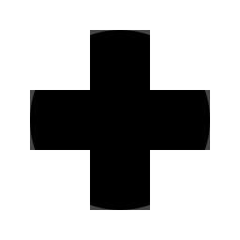
Next to health are Strength, Shield, and Keys.
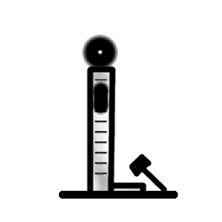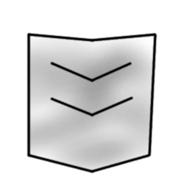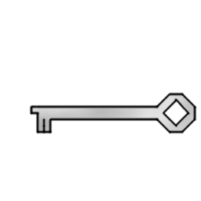

Next to ammo are the powerups: Turbo, Night vision, Lift belt, and Radar.{\Scrv_annot \color={\R=1.000000\G=0.000000\B=0.000000} \text=TODO: update this when finalized\end_Scrv_annot}


Crosshair: fine lines, duplex (outer parts of lines highlighted); also dot and range-finding for long-range weapons.

